TRAINING REPORT
ON Advanced Python
SUMMER INTERSHIP
Submitted to
Faculty of Computers and Artificial Intelligence
In partial fulfillment of the requirements
for the award of the degree
BACHELOR OF Computer Sciences
(Semester - IV)

Place: Public service center
Date: 23/9/2023
Submitted by: Abdelhaq Adel
Student’s Name: Abdelhaq Adel
Student’s Signature: abdelhaq
ID: 2031032

ACKNOWLEDGEMENTS
Note to Students:
Acknowledgements to be mentioned to the Head of the Extended Learning Centre, Faculty guide, Training Officer in charge. Manager in charge, other staff members, colleagues and friends for their encouragement, support, guidance and assistance for undergoing successful management training and preparing the Training Report.

CONTENTS
CHAPTER 1: INTRODUCTIOM ON TRAINING

CHAPTER 2: basics of python
- Variables defination
- Arithmetic operations
- Comparison operators
- Data Types
- Rando numbers
- If Statements
- While loops
- For loops
- Variables
- Functions
- Data Structures

CHAPTER 3: NumPy library

- Creating NumPy Arrays.
- NumPy Attributes.
- Creating Arrays Using Methods.

CHAPTER 4: Pandas library

- Read CSV Files.
- Series.
- Data Frame.
- Functions

CHAPTER 5: Matplotlib library

1. Plotting
2. Scatter
3. Bars
4. Histograms
5. Pie charts

CHAPTER 6 pillow (Image library)
Chapter 1: introduction on python
Python is a high-level and versatile programming language known for its simplicity and readability. It was created by Guido van Rossum.
Python has gained immense popularity in various fields, including :
- web development.
- data analysis.
- machine learning.
- and scientific computing.
- Why python?
- Readability: Python's syntax is designed to be clear and easy to understand, making it an excellent choice for beginners and experienced programmers
- Versatility: Python can be used for a wide range of applications

Chapter 1: Python basics

2.1 Variables definition
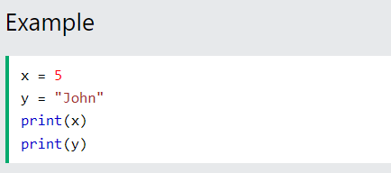
If you want to specify the data type of a variable, this can be done with casting
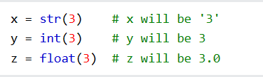

  - Arithmetic Operations
1- adding numbers in python 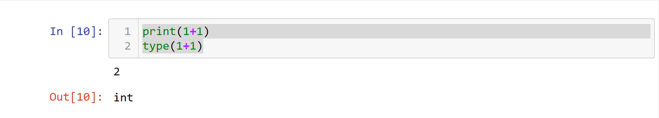

2- dividing numbers in python
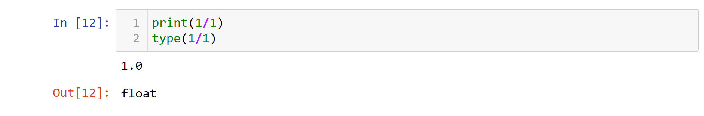

3- multiplying strings by a scaler in python
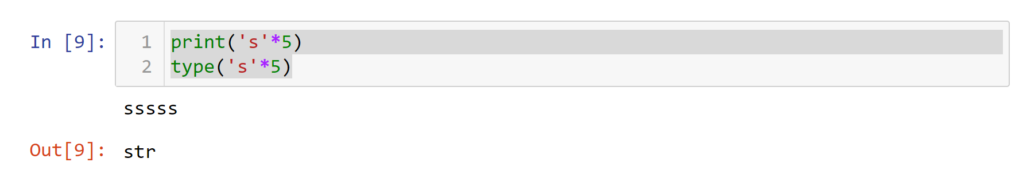
4- adding a number to a string in python
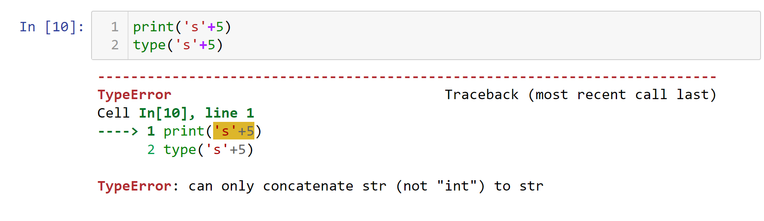

2.3 Comparison Operators
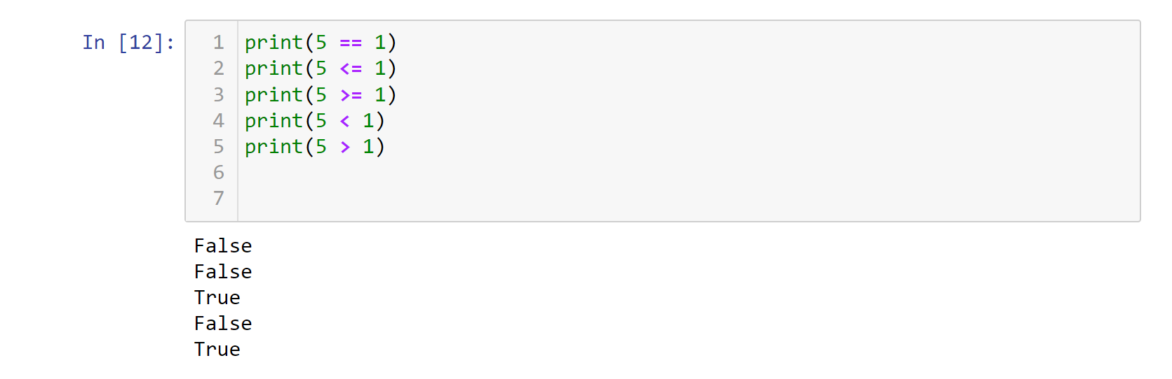

2, 4 Data Types
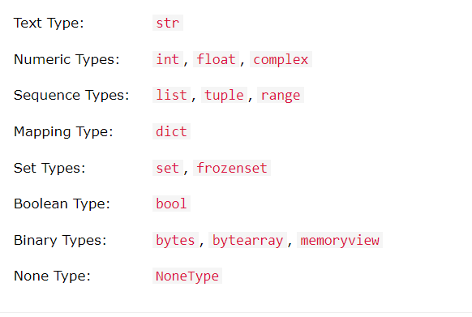
- We can get the data type of any object by using the type() function:
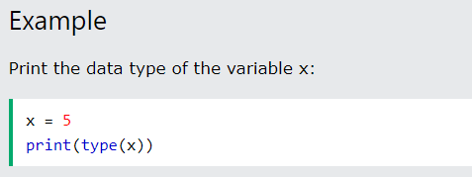
  - Random number
Python does not have a random() function to make a random number, but Python has a built-in module called random that can be used to make random numbers:
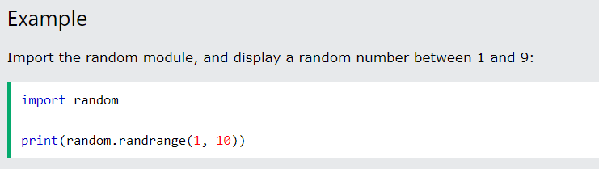

2, 6 If Statements
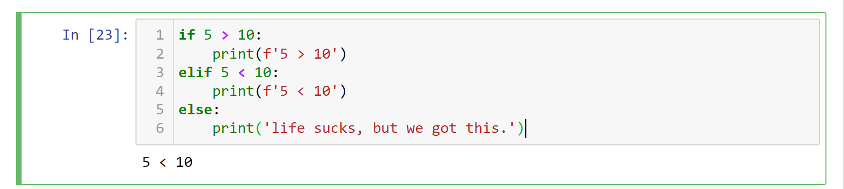

LOOPS:
2, 7 While loops
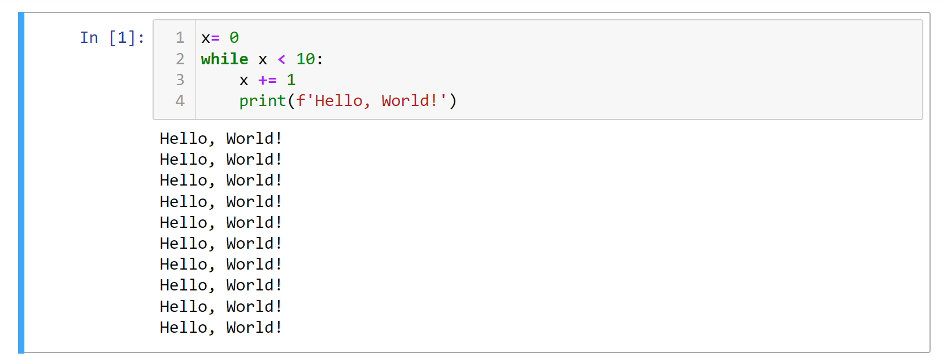
2, 8 For loop
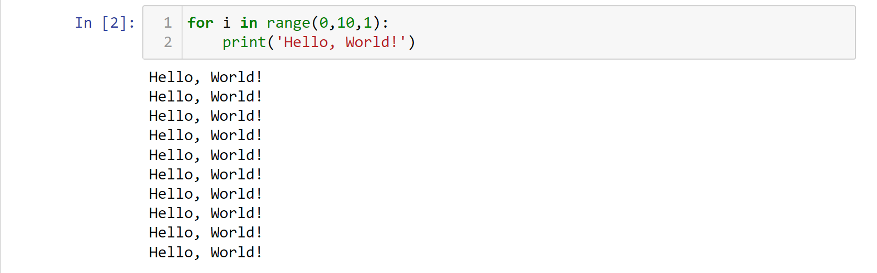
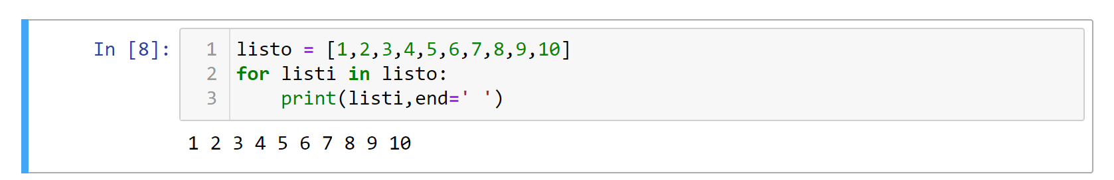

2, 9 Variables
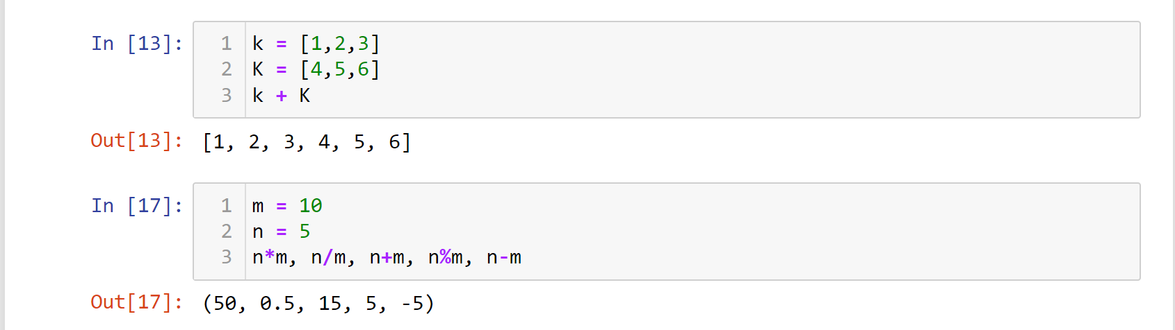

2, 10 Functions
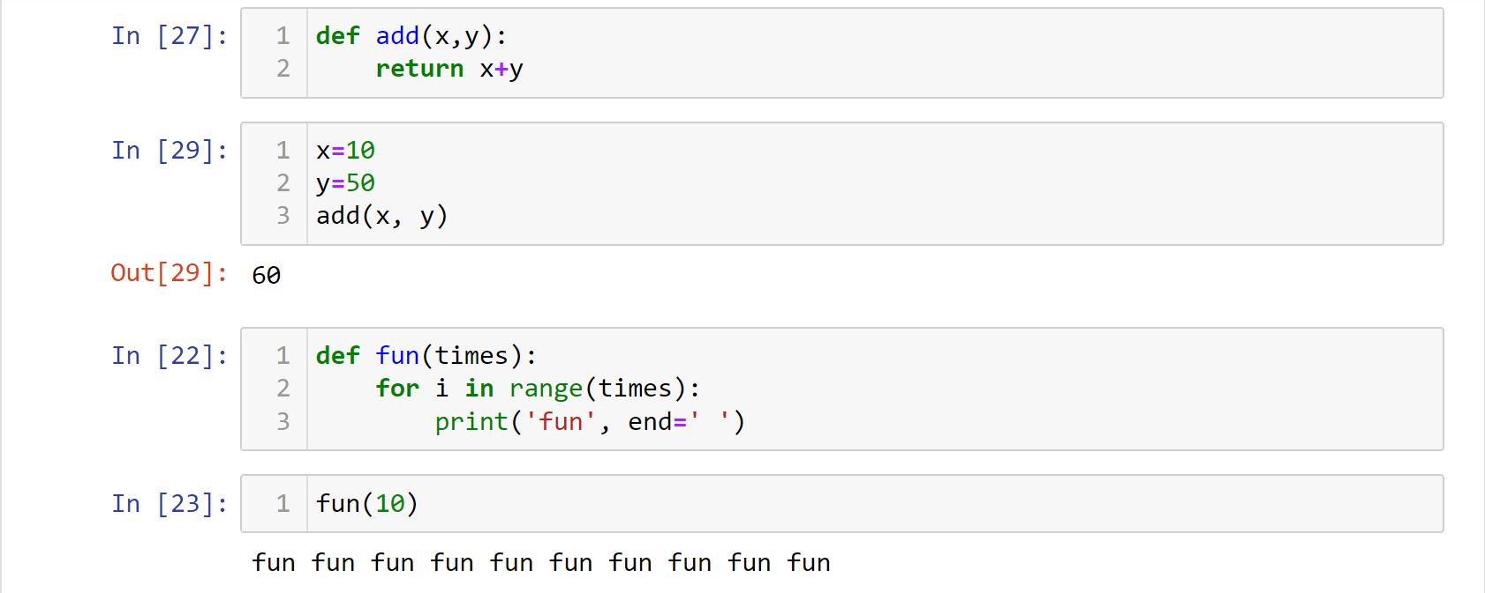

Data Structure :
Data Structures are a way of organizing data so that it can be accessed more efficiently depending upon the situation. Data Structures are fundamentals of any programming language around which a program is built. Python helps to learn the fundamental of these data structures in a simpler way as compared to other programming languages.

2, 11 Lists

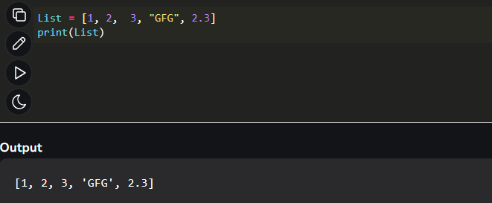
some operations in list:
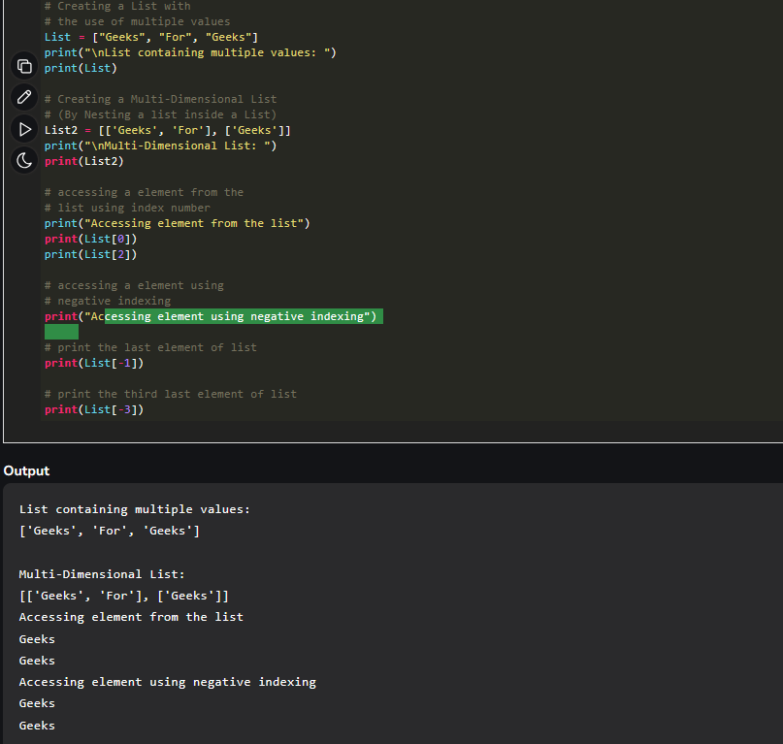

Tuples
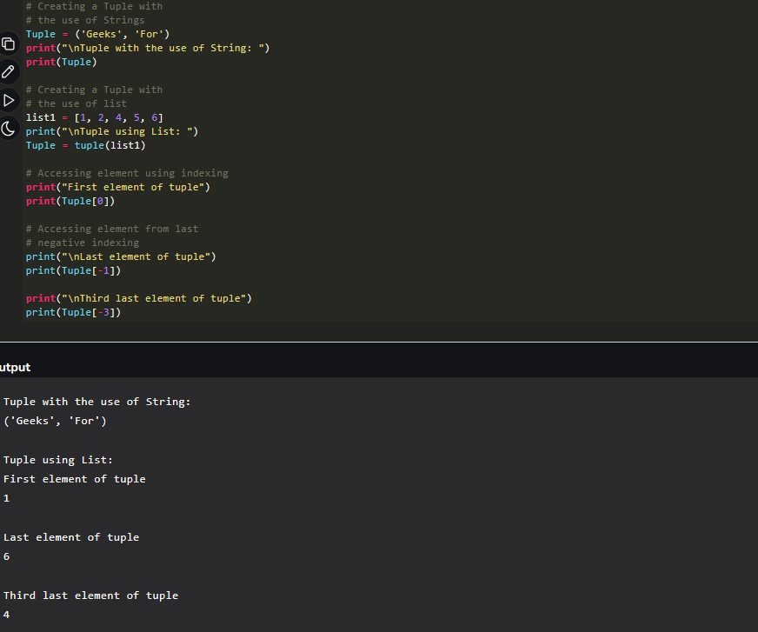

Sets
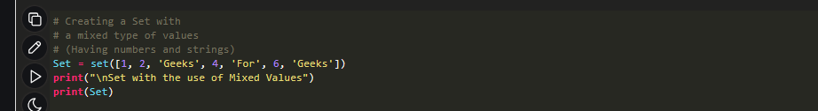
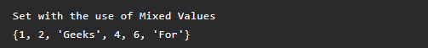

Dictionaries
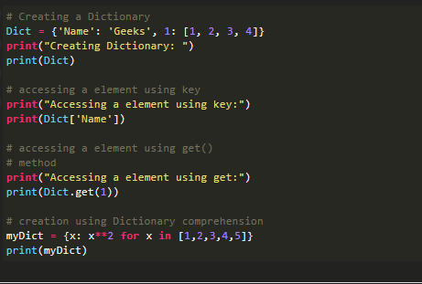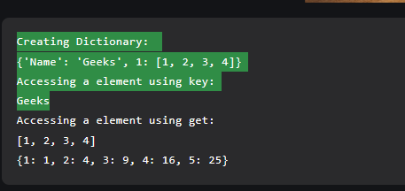

All libraries :
Chapter 3,1:(NumPy)
3.1 Creating NumPy arrays
NumPy is a Python library used for working with arrays.
This library for creating a NumPy array using the np.array method.
First importing NumPy

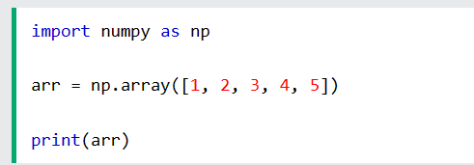
3.2 NumPy Attributes, functions:
Some methods in NumPy library
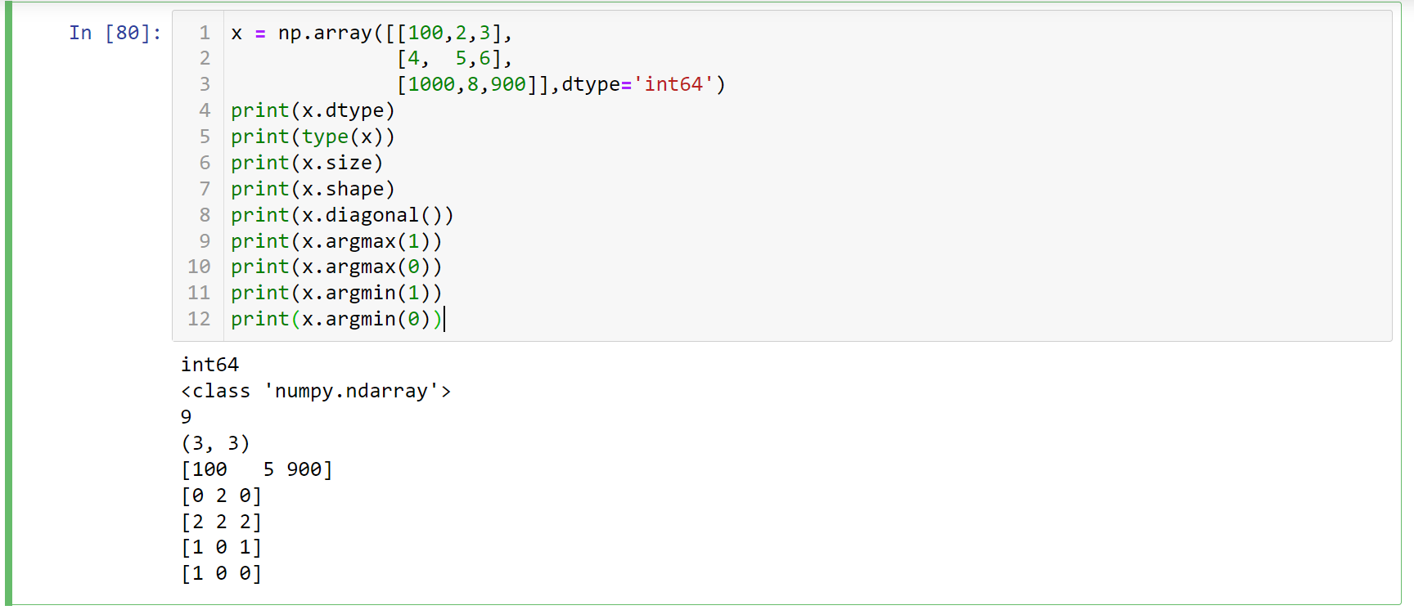
3.3 Creating NumPy arrays using methods
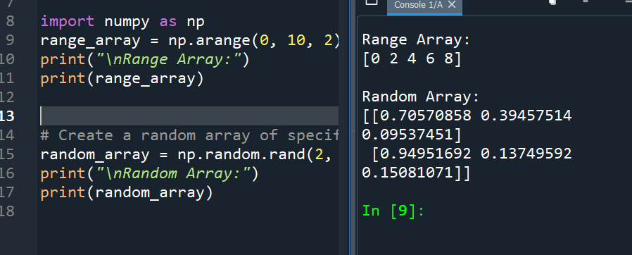

Chapter 4,1(Pandas)
4.1 Reading CSV Files
Using pd.read_cv method we can read any file by Write the file name
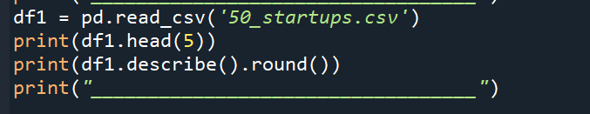
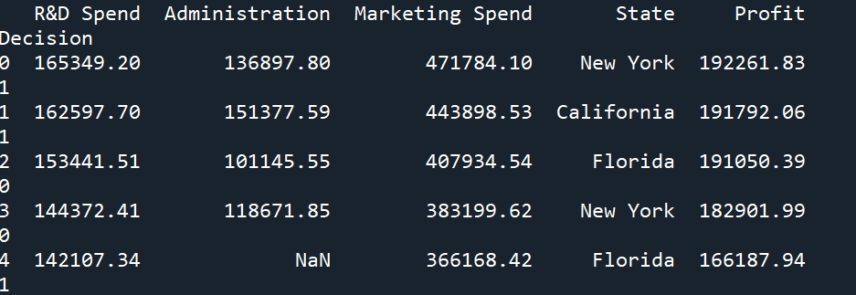

4.2 Series
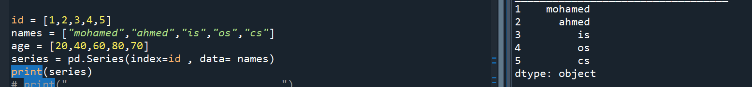

4.3 Data Frame
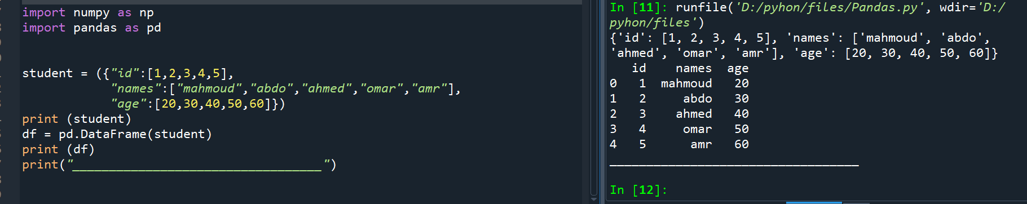

4.4 Some Functions in pandas

We can make some operations to this file :
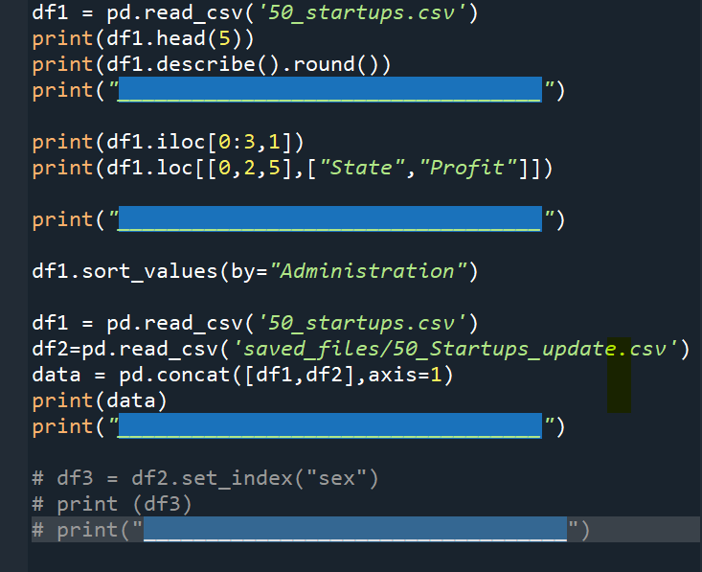

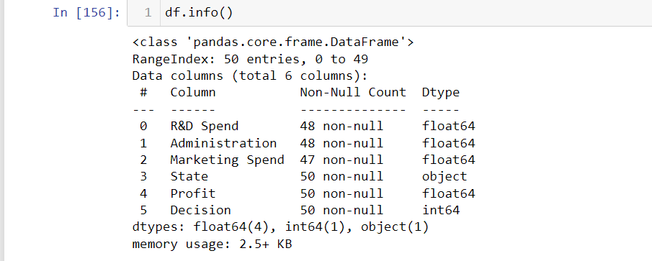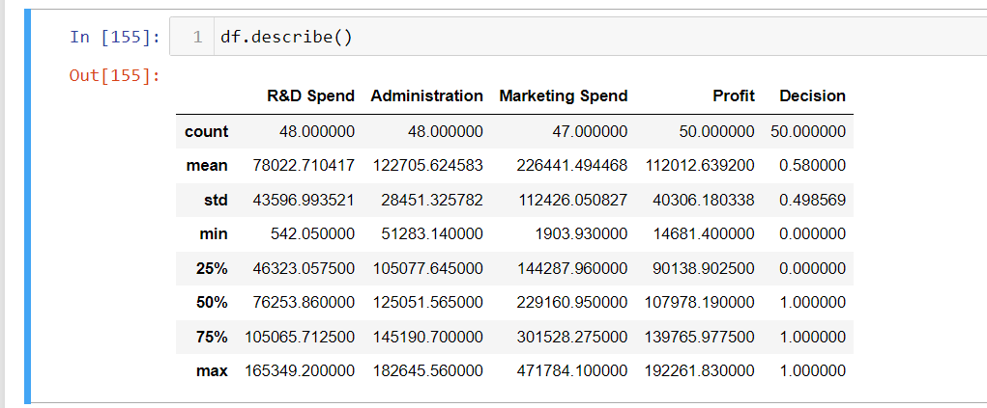
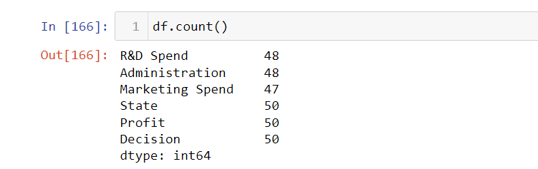
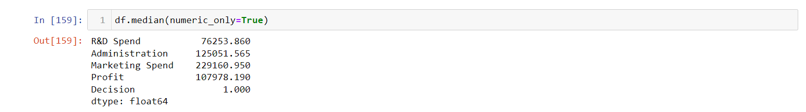
Chapter 5,1(Matplotlib)
Pie

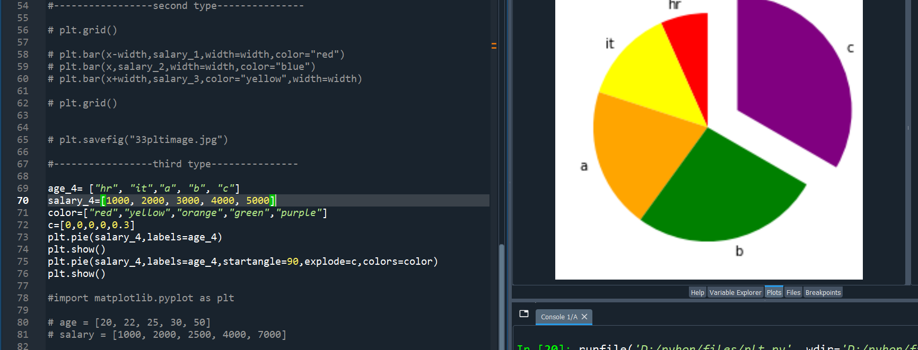

plot
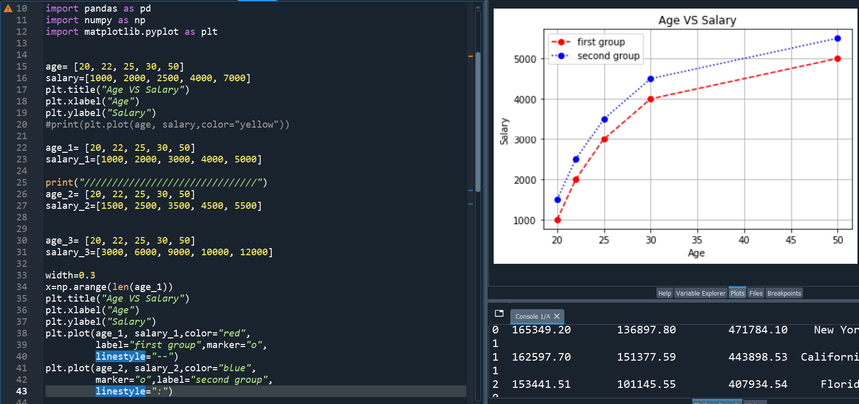

Scatter Plot
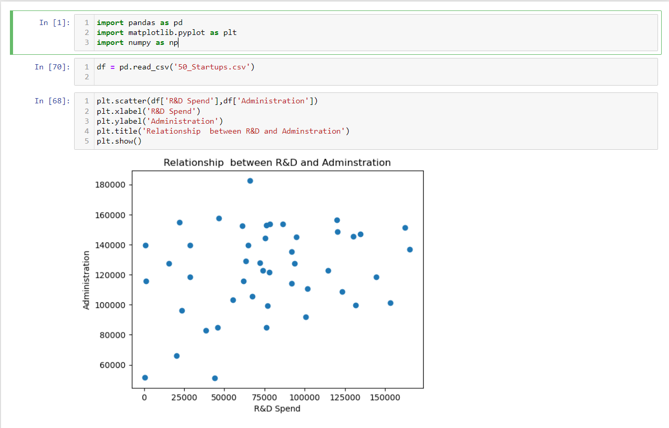
Histogram 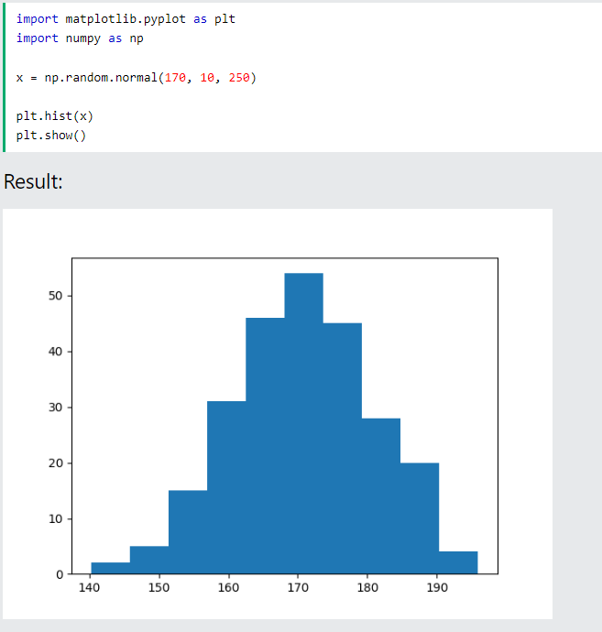

Bars
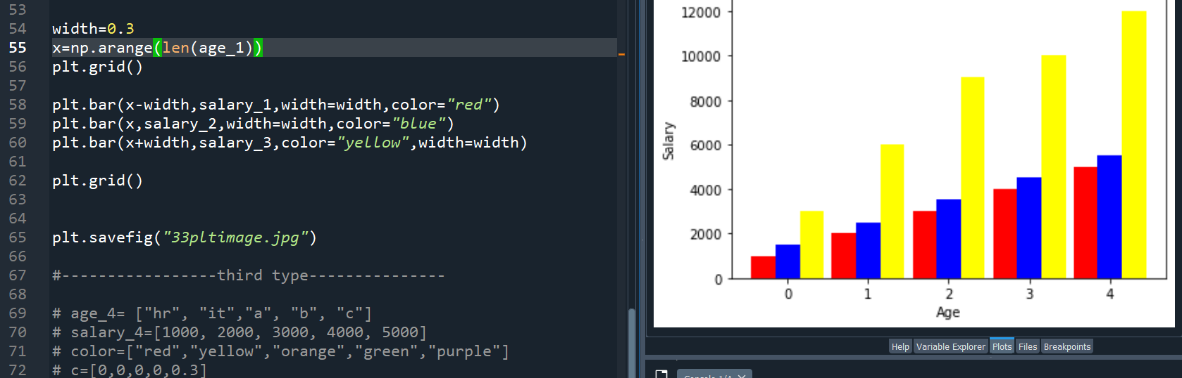

CHAPTER 6 pillow

Pillow is the friendly PIL fork ,
PIL is the Python Imaging Library by Fredrik Lundh and Contributors
We import Image Lib:
The Python Imaging Library adds image processing capabilities to your Python interpreter.
This library provides extensive file format support, an efficient internal representation, and fairly powerful image processing capabilities.
The core image library is designed for fast access to data stored in a few basic pixel formats. It should provide a solid foundation for a general image processing tool.

- Import image library :

From PIL import image
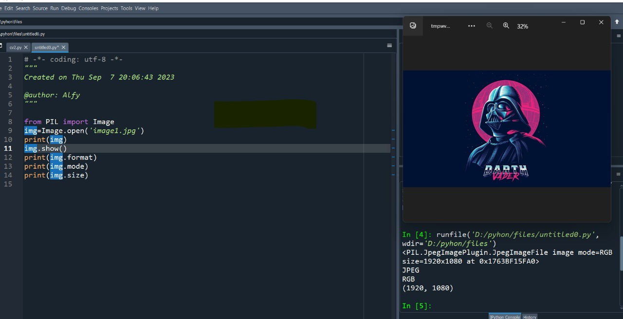

2-using some methods to make some operation on this image
Crop (cutting of image)
Rotate (to rotate the image by the grade )
Transpose (change rotate)
Convert (edit color of image)
Median (add filter to image)

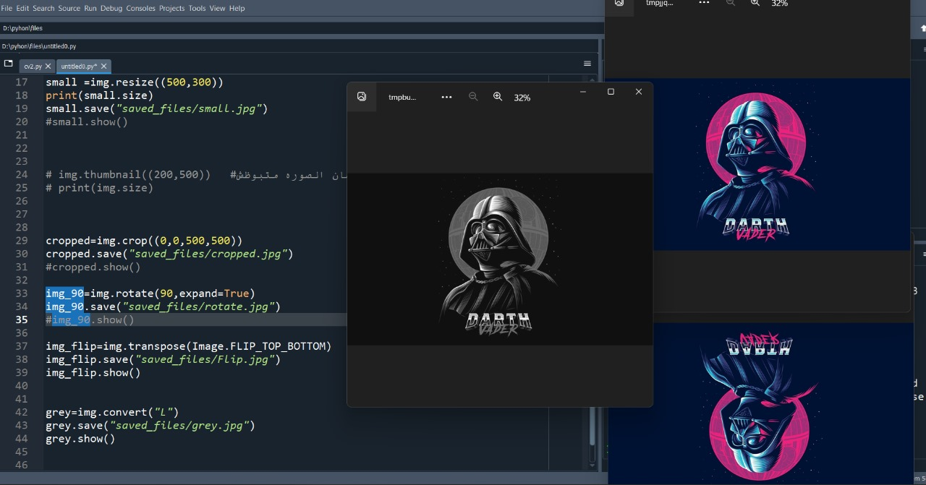

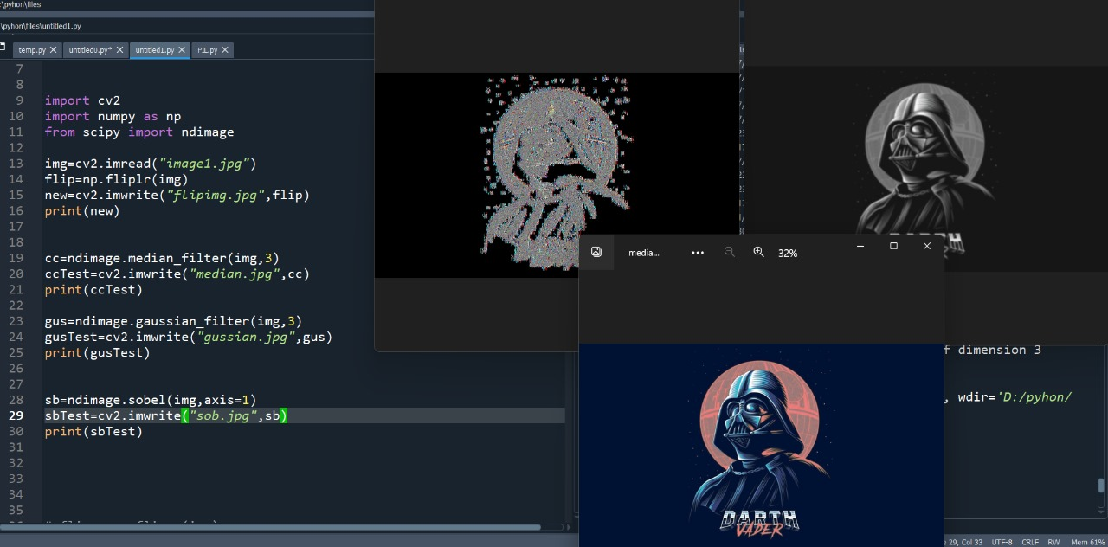
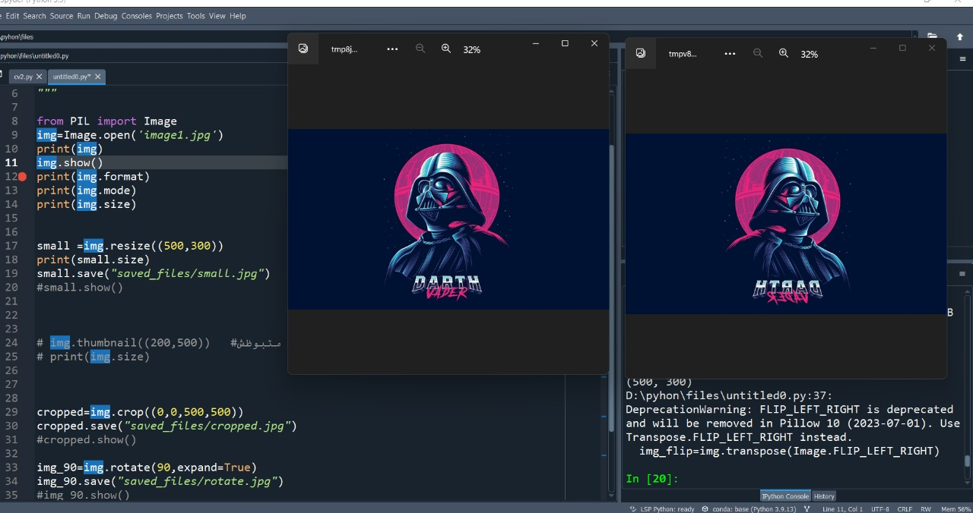

Seaborn library

Seaborn is a Python data visualization library based on matplotlib. It provides a high-level interface for drawing attractive and informative statistical graphics.

For a brief introduction to the ideas behind the library, you can read the introductory notes or the paper. Visit the installation page to see how you can download the package and get started with it. You can browse the example gallery to see some of the things that you can do with seaborn, and then check out the tutorials or API reference to find out how.

To see the code or report a bug, please visit the GitHub repository. General support questions are most at home on stackoverflow, which has a dedicated channel for seaborn
